**Critical research and game concept**

In this report I have researched a variety of zombie-like games to help inspire the concept art and designs for a new zombie shooter game I am going to make.

The first game that I have researched is 7 days to die. I’ve chosen this game because I have played it before and I know good knowledge behind it like the mechanics, style of the game and how zombies react to the player and objects. The game is about building, looting and crafting in order to survive the zombie apocalypse, It also has a unique combination of fps, survival horror and tower defense elements in it. (Gamepedia, 2019) this combination works very well in this game because during the day you mostly go out and explore, looting things from abandoned homes etc. but when it reaches night time, the amount of zombies is increased and you are tasked to defend your home base for the night. This mix of gameplay styles keeps the game being fresh and always makes the player have something to think of what to do next in a scenario.

The developers have gone for a realistic approach in terms of interactive things in the game like weapons, outfits, houses and gameplay this works well with the game because they clearly wanted to make the game as real as possible to maybe replicate what it could look like if a zombie outbreak occurred. However, when it comes to enemies, they’re a little exaggerated. There are zombies in the game, but not only human zombies with different roles like hazmat suits or police officers, they also have zombie dogs, bears and vultures which are a variety of random animals to add to the game. These zombies change the game quite drastically because if you come across a lot of them, its best to avoid them as they can kill the player quite easily (7daystodiegamepedia, n.d.) This makes the player think more about if they should loot the place where those zombies are or killing them to get a pickup from them or just ignoring the location. Each way could impact in a variety of ways on the player.

7 days to die is available on the Xbox one, pc and PlayStation 4. (metacritic, 2019) they have also chosen the target audience for mature people, so roughly 18 and over, due to its gore elements when killing zombies and some quite disturbing sounds when its nighttime.

Going through some user reviews on Metacritic, I have found that there is a mix of reviews for the game some saying that its great and has so much potential if they would keep updating the game quite frequently and others saying they’ve spent thousands of hours building bases, towns and killing zombies with their friends. However there has been some people reviewing the game that specifically on Xbox and PlayStation, the game doesn’t run well at all and should consider getting it for the pc, some have also complained about the visual style in the game saying it looks years old with minimal objects in fields etc. and also plagued with performance issues. (metacritic, metacritic, n.d.)

Things I could take from this is perhaps a sandbox style mode with making houses and bases maybe some custom levels for a game, so imagination is endless for the game. Things that would need to be checked thoroughly is the code or change some models and assets to prevent performance issues. In terms of visuals, I would try to make the game look up to date with shadows, assets detail like characters and zombies also lots of vegetation because if there’s only a small amount it doesn’t really look realistic to prevent the game looking old.

The second game I have chosen as inspiration for my zombie game is halo. Although halo isn’t classed as a zombie shooter, the franchise still includes zombie like elements in most of their games. These zombie-like elements I will be taking inspiration from is the race known as the flood which is first seen in halo combat evolved (halo ce). (xy274, 2011) halo CE is a fps sci fi game where you are tasked with defeating an alien force called the covenant. It’s also using linear gameplay meaning that it consists of multiple missions you progress through each being at different locations.

The game and other titles have a mixture of gameplay styles as specific missions could be survival based, wave based. One mission for example is from halo reach, this is the end mission called lone wolf where you are tasked to survive as long as possible against the covenant. (fandom, n.d.) Another example would be from halo 2 the mission called the arbiter and there’s elevators you must go up with several waves of flood attacking you until you reach the top. (fandom, halofandom, n.d.) These gameplay elements really give the game more emotion because it shows how overwhelmed your player is compared to the covenant and flood and also gives some variety in the game to keep it fresh and make players want to keep playing.

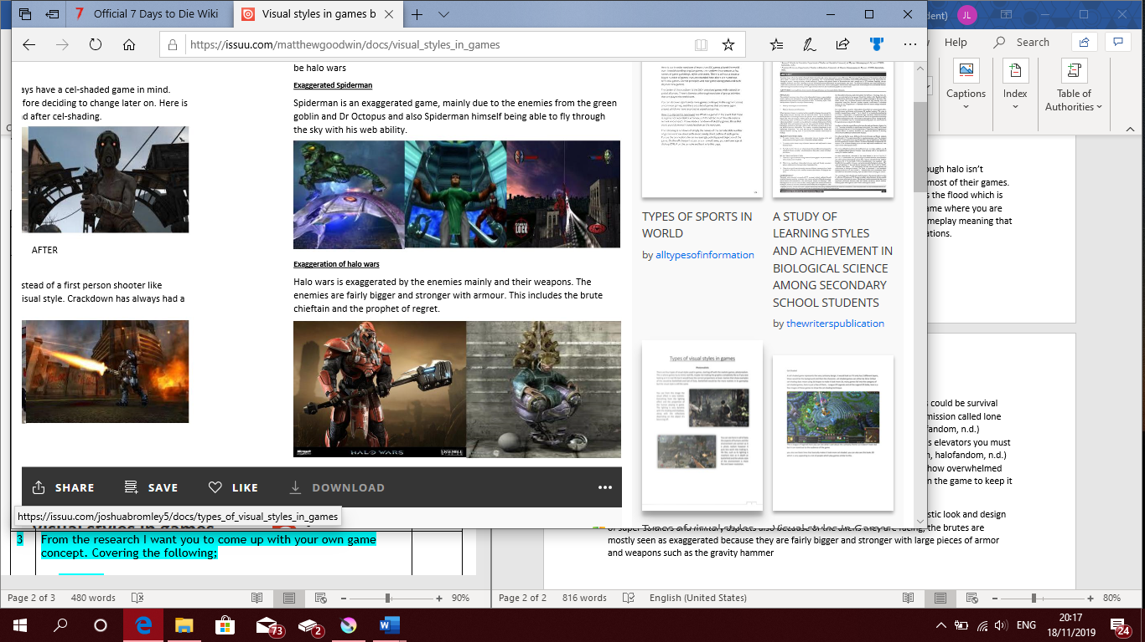The visual style of this game goes for an exaggerated approach due to the futuristic look and design of super soldiers and military aspects also because of the aliens they are facing, the brutes are the most exaggerated out of others because they are fairly bigger and stronger with large pieces of armor and weapons such as the gravity hammer being very large, and rocket launchers also being unnaturally large. (fluroclad, 2010) I think the exaggerated style is a good choice because it shows how strong either side of the war is with very large and powerful weapons and armor.

The target audience that they have chosen for this game is mostly towards teenagers and older because it has the option to make the game punishingly difficult and it is however likely to appeal more to males as we are on average more inclined to enjoy more violent styles of games like Call of duty or star wars. (Kenny, 2015) The platforms that are available for this game are the Xbox eventually the master chief collection on the PC.

halo combat evolved at launch was one of the best games and best rating reviews with lots of players complimenting the game to be the best. Some of these say that it is an immersive sci-fi epic, it has an awesome story, its attention to detail visually and its narrative also that it was the closest thing to a living breathing alternate universe. (metacritic, metacritic, 2001) These reviews were between its launch and roughly 2005 so compared to games nowadays attention to detail was actually very basic along with its story.

Things I could use from this game is the exaggerated style of the covenant enemies because I also want my zombies to not have a very natural look like 7 days to die zombies. Another thing would be the unnaturally large weapons like the gravity hammer to force away lots of enemies at once.

The final game that I have researched is Call of Duty Black ops 2. Although this game doesn’t focus on zombies in its main story and multiplayer, it does have a zombie specific mode within the game. I have chosen this because the mode focuses on the zombies and how, why they have come to life it also has a very in-depth story linking previous and newer games in the COD franchise. (matt, 2019) The main aim of the game is to survive as many rounds as you can within a confined are where you can open doors and locations to find perks and new weapons to help survive longer. It is a wave-based mode so there is a certain number of zombies per round, each round getting progressively harder as you pass each round. (codfandom, n.d.) this gameplay style fits the mode well because it gives players the chance to try and get high scores in the mode reaching hundreds of waves or thousands of points. It also makes you want to try and beat your previous score, so it has plenty of replay ability this is also the same with trying to do easter eggs and hidden story quests in the mode.

The developers have gone for a realistic visual style to suit the game best because the game is mainly focused on modern military warfare as well as ww2 and ww1. But other games in the franchise, as well as other zombies’ modes, they go for an exaggerated look take infinite warfare and advanced warfare for example. This may be because one game is set in the future or in an alternate past like in zombies’ black ops 4. black ops 4 specifically features wizard like staffs and spells or weapons also strange red teleports that transport you around the ship. (duty, 2018) thus, making the game have an exaggerated look.

Platforms that these games are available on are PC, Xbox and PlayStation also with black ops, modern warfare and world at war being on the Nintendo WII (amazon, n.d.) he developers also planned for the target audience to be for mature people so mostly 18 and above because of its complex story, blood and gore seen in cutscenes and gameplay also its violence with weapons.

Reviews for call of duty black ops 2 specifically are mostly positive as seen on steam with a lot of players saying that it was one of the best games in the franchise sometimes 2nd to modern warfare 2, the campaign is fantastic and that the zombie storyline is the best and brings the experience from the first black ops. Some reviews say other wise and think that the campaign was one of the worst and that multiplayer is always hacked and you can’t find an unhacked lobby. (steam, 2012) Another problem was that the game is way overpriced considering it is nearly 7 years old since release. (bing, 2012)

One thing that I have taken as inspiration is the storyline for the zombie’s mode because they have linked it very well with the previous game black ops. The easter eggs and hidden quests you need to do I have also considered adding to my game. The look of the maps with lots of smoke and ash almost blinding the players vision when playing and finally the exaggerated zombie art style with the red glowing eyes, the melted look of the zombies skin, the way they walk and run also that they can survive in lava.

**Concepts for my game**

Story of my game:

You are stranded on an unknown planet with limited supplies by your side. You stand up to find one of your fleet’s ships crashing into the planet not far from your position. There is also another ship crashed not far from where you are. You are tasked to explore the planet and survive horrific creatures from deep within the planets crust. There may be some hidden locations with special upgrades and weapons that you can use to survive longer. the planet seems to have a desert like look to it, but it has lots of vegetation and weird alien houses or farms. Large thick dust storms blind some areas of the planet, so you don’t know what’s there until it clears.

The weapon the player would first start off with is a pistol which was attached to him as he fell from the ship, but other weapons can be found and upgraded. Core elements of gameplay would involve walking, running, jumping, shooting and crouching to help sneak past enemies. The HUD would display the amount of ammo the character has left in the weapon currently equipped; it will also show the players shield and health bar, a reticle to help with aiming the weapon at enemies and finally a score tracker to keep track of the players points.

The visual style I have gone for is exaggerated because I wanted to have strange alien like creatures as the zombies, the main character would be an astronaut that doesn’t look like the suit has much protection and looks kind of like a raiders outfit from the game fallout or mad max film. Another big reason is because the location is on a unique planet with lots of different things that’s likely not seen before such as unknown farmhouses or strange looking plants that are growing in a desert.

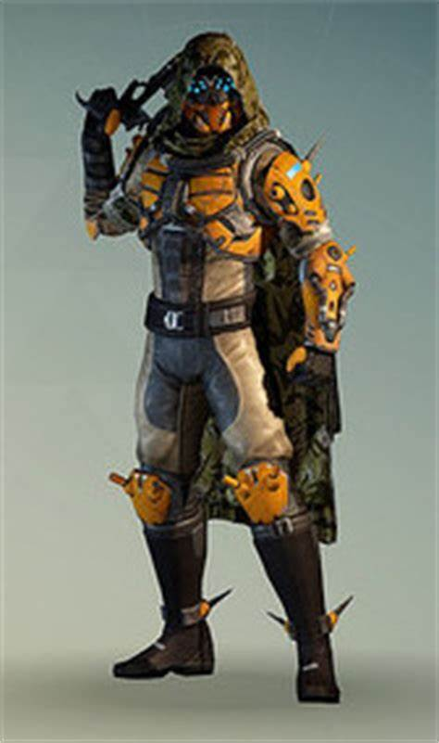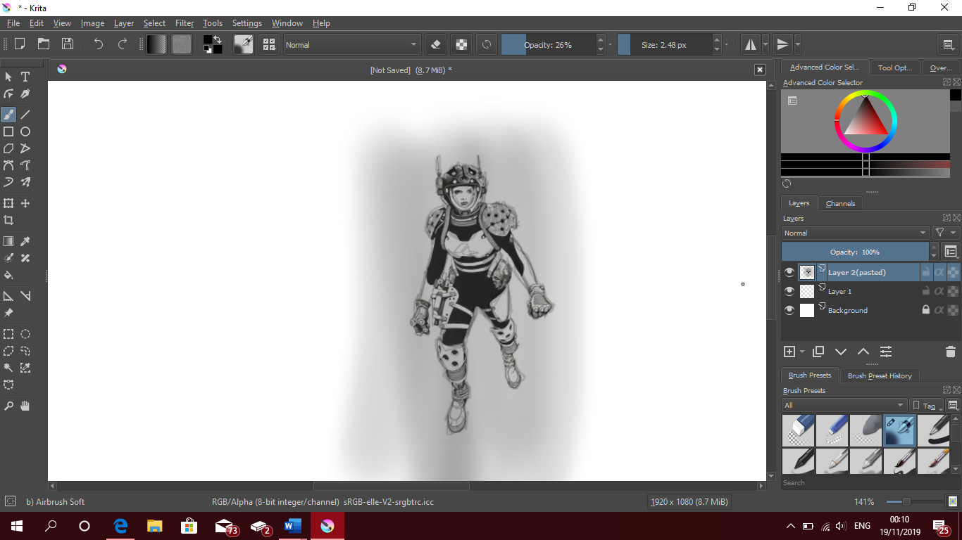This is the main character design for the game. I have gone for a female who has a damaged look on the spacesuit. I have given the character limited armor because they have just been involved in a crash and have lost some pieces of the suit like the fore arms and waist. I have given the suit that outlandish look so it looks out of place and seems to not look right for the situation they are in. the holes in the armor I thought was a good choice because it helps define each piece more rather than it being a plane flat plate of armor.

I have also given them a holster for the pistol which you start off the game with because I think it would make sense to have a weapon which was stuck to you throughout the crash so you have some form of protection other than melee combat. This pistol design was also taken from the halo magnum which is featured in almost every halo game. The armor was inspired from 2 games destiny and halo. I used destiny because I really liked the way the fallen arms armor looked like for the hunter with lots of circles mixed in it. This is the same with the spikes as I just thought to remove the spikes and just have holes in its place. I chose halo’s master chief as influence because of the large shoulder plates he has, and I thought I could also have large shoulder plates to fit with the design.

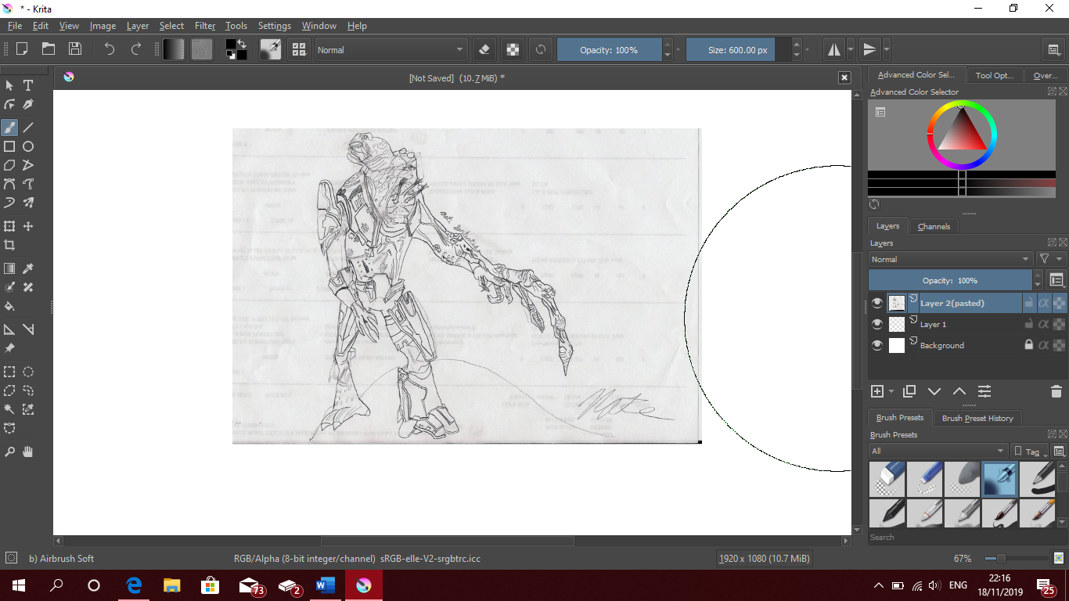as for the enemy in my game, I have gone for a very similar look to the flood from the halo franchise. I have done this because I really like how the branches of the floods arms and tentacles branch out randomly and also how they infect and turn other species to transform into those creatures. As for my interpretation of the flood, I have given the creature more armor so that it has more protection and would be harder to kill. I have also given it a much larger branched arm so that they can swing from long distances. The weapons this creature has is only its tentacle branch because I think if they had weapons, the game would be too difficult.

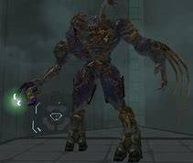This would not be the only design of the zombie as I plan to also do large flying animals that swoop down and attack the player with its beak. Inspiration for that design I would probably use the vulture from 7 days to die.

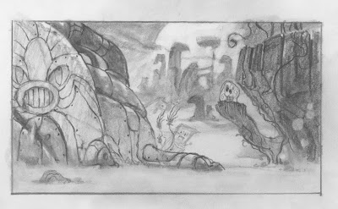This is a rough sketch on the level design I’m hoping to see in this game. It features a large alien like house to the right with unique details on it. There’s a cliff edge over to the left because I thought some form of verticality in the game would be good to give some more depth in the game and trying to make the player question what’s over there? And finally, in the background there is a bunch of plants and trees which cover a large area of land kind of resembling a jungle. In between the house and the trees and plants in the background is a vast sand plane with nothing but small vegetated areas with some water. This design was influenced from the call of duty zombie’s mode the Egypt map. But rather than just having pyramids and just small villages, I wanted to make it seem unnatural to look at so I gave it more plants that are growing in desert sand.

In conclusion I have found this research to be very helpful when making concepts for my game. The exaggerated art style which I have chosen fits very well with my game idea because the game features lots of unique elements and some very unnatural elements also strange looking zombie like creatures varying in shape and size. The concepts I have created so far have been pretty good and summarize the idea quite clearly, I think also I really like how the main character turned out. One thing I would change slightly is the enemy design because it is extremely similar to the flood from halo so I would hope to make change the armor design or have the parasite only change the part of the body it touched or infected to make it more unique. The research into 7 days to die has also helped quite a lot because almost half of the reviews didn’t really enjoy it so it showed me what to avoid such as lack of detail and level design in 7 days to die. Overall the idea and concept for this game have been good in terms of detail but one thing I would need to do is create more concepts of e.g. interactive objects like ropes or levers.